 FOR IMMEDIATE RELEASE

For further information please contact: www.quintgallery.com
Anna Quint, 858.454.3409 info@quintgallery.com

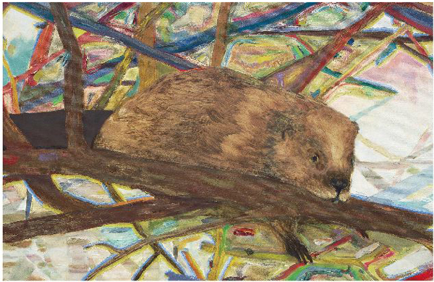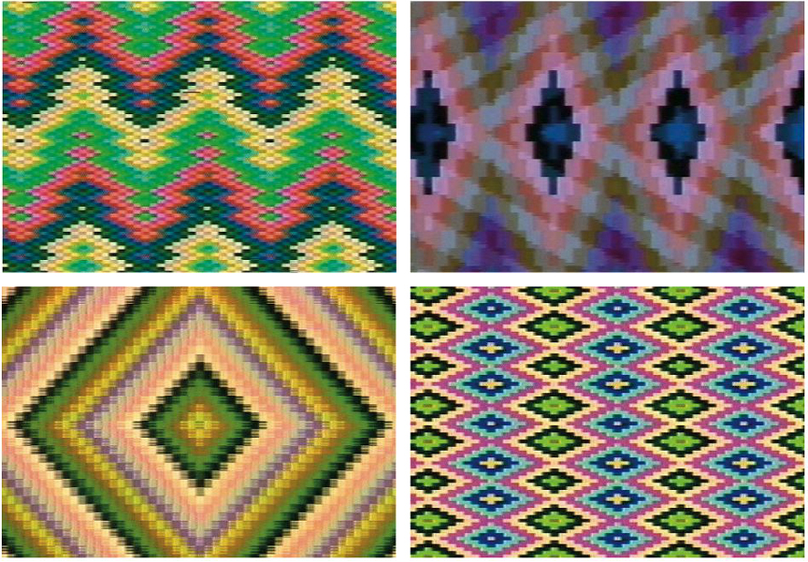

Beaver Painting and VIDEO WEAVINGS #5

May 21 through June 18, 2005

La Jolla, CA- Quint Contemporary Art is pleased to announce two exhibitions taking place in May Matthew Offenbacher, Beaver Painting and Stephen Beck, Video Weavings #5.

Matthew Offenbacher will be showing a new series of work titled Beaver Paintings. This will be Matthew’s second exhibition at QCA and is a continuation of the artist’s interest in the relationships between man, animal, nature and art. Using the beaver as a metaphor for the artist, Matthew imagines a harmonic art world, a sort of 60’s bliss, one in which the craftsmanship of woven “God’s Eyes”, macramé and colored prisms share a stage with nature and a “back to the land” mentality. The beavers, amazing dam/house builders (or sculptors) of earth, wood and water, stare out at the viewer, at once humanizing themselves but at the same time functioning as the exotic other: the mysterious other onto which idealist fantasies can be projected. Along side the large beaver paintings Matthew will also exhibit small geometric paintings that harken back to early cubist works by Picasso and Braque, paintings that were methodical and analytical yet deliberately primitive, strange and alien. These are paintings Matthew imagines the beavers creating if they were artists.

Stephen Beck is a video artist who has been sculpting video and multimedia works since the pre-digital era of the 1970’s. “Video Weavings #5”, 1974, is considered one of the pioneer works in the field of digital video synthesis, using the warp and weft of the televisions electrons to create patters on the video recording. The work operates through the fundamentals of the matrix, a basic format of life, in fusing the modern technologies of the video with the ancient methods of weaving inspired by the Ancient peoples of India, Australia, Africa and North America.

In an attempt to translate the algorithms of television mechanics into traditional weaving patterns on video, Beck had invented “The Beck Direct Video Synthesizer” played and recorded in real time to create the various patterns that resemble or replicate traditional patterns of weaving. As an early video work created in the analog video era, “Video Weavings” featured a multitude of colors and unique patterns some of which could not be generated or seen with a normal TV or video of its time.

Stephen Beck’s work has been exhibited in various venues including the Museum of Modern Art in New York, the Kwang Ju Biennale in Korea, Tate Modern in London, Pompidou Center in Paris and is currently on view in the Museum of Contemporary Art Los Angeles1

There will be a public reception for the artist on Saturday, May 21, 2005 from 6 to 8 pm

Gallery hours: Tuesday through Saturday, 10 to 5:30 and by appointment

P.O. Box 1172, La Jolla, CA 92038•T-858-454-3409•F-858-454-3421• www.quintgallery.com

