FOR IMMEDIATE RELEASE

For further information please contact: www.quintgallery.com

Katie Lewis info@quintgallery.com

858.454.3409

KIM MacCONNEL

If You Study This Work You Will Benefit

October 18 – November 23, 2002

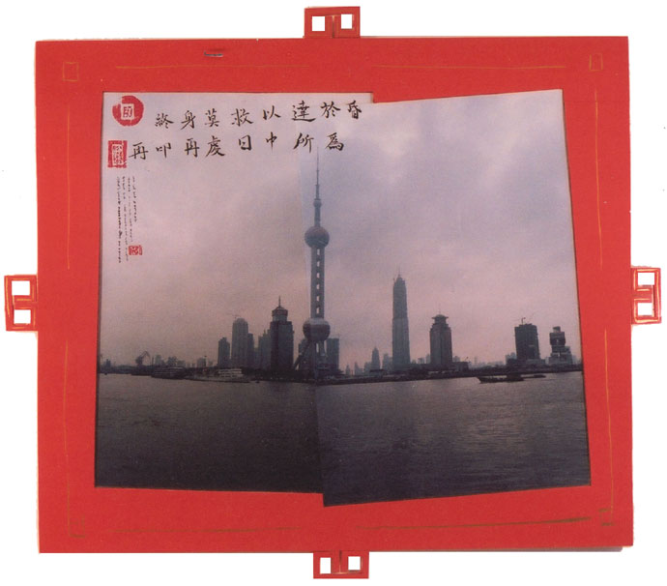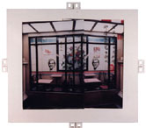

Kim MacConnel’s fifth solo exhibition at the gallery features scenes photographed during the artist’s trip to China. This series furthers the artist’s interest in the visual fabric of other cultures. MacConnel took as his muse a poem from 14th century Chinese scholar Liu Ji which imparts small pieces of wisdom by which one can live his/her life. He chose this old piece of writing because, in his own words, it “possesses a certain amount of modernity that parallels that which is captured in the photographs.” The particular scenes chosen are meant to evoke traditional Chinese landscape imagery while retaining signs of our own times. Old and new collide forcefully and unmistakably. A modern skyline full of modern buildings recalls ancient mountain paintings with its atmospheric touch, and the interior of a fast food restaurant resembles old-fashioned temple architecture. Each scene is paired with a couplet from Liu Ji’s poem that is written in calligraphy on the image in both Chinese and English.

Kim MacConnel completed both his BA and MFA at the University of California at San Diego. MacConnel’s work has been included in the Whitney Biennial four times and the Venice Biennale two times. The artist has enjoyed solo exhibitions at the Aspen Art Museum, CO; California Center for the Arts, Escondido, CA; and the Museum of Contemporary Art San Diego, La Jolla, CA. MacConnel’s many group shows include installations at the Museum of Modern Art, New York; P.S.1, Long Island City, NY; and the National Gallery, Washington, D.C.

There will be a public reception on
Friday, October 18, 2002 from 6 pm to 8 pm
Hours: Tuesday through Saturday, 10 to 5:30 and by appointment

